**LEBANESE AMERICAN UNIVERSITY**

**USAID – HIGHER EDUCATION SCHOLARSHIP PROGRAM**

**HES - Volunteering Program Verification Form**

This form is to be used to document volunteering hours. If a student volunteers for multiple organizations, a separate form must be used for each organization. **This form must be turned in by the 28th of each month, the latest.**

I certify that the scholar Asmaa Abd almohti Almasri completed a total of 25 hours of service at InnovaThrive.

The hours were completed hours as per the below:

Hours # 5 (date) _4/11 – 8/11_ (initials of supervisor) __A.K.___

Hours # 8 (date) _11/11 – 15/11_ (initials of supervisor) __A.K.___

Hours # 7 date) _18/11 – 22/11 (initials of supervisor) __A.K.___

Hours # 5 date) _25/11 - 29/11 (initials of supervisor) __A.K.___

Brief description of the activities the scholar performed or participated in:

the first research: counseling program, some modifications were needed for the reference list and the appearance.  
the second: the psychological effects of color in marketing, the whole research was edited; changed the bullets into paragraphs, apply the template of InnovaThrive, referencing, and some edits for the language.

Written feedback about the scholar’s performance:

Asmaa's ability to refine and enhance research documents, from language editing to formatting, showcases her attention to detail and commitment to quality. Her work on the psychological effects of color in marketing demonstrates her versatility and dedication.

Please rate the overall performance of the scholar at your organization:

|  |  |  |  |
| --- | --- | --- | --- |
|  | Mastery (5) | Proficient (3) | Emerging (1) |
| **Problem solver** | X |  |  |
| **Engaged & Committed** | X |  |  |
| **Open-minded & multicultural** | X |  |  |

Signature

& stamp

__________________________

_

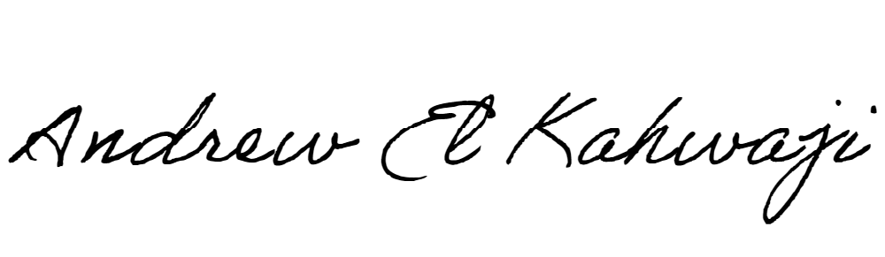

Printed Name _Andrew El Kahwaji_

Date __26/11/2024___

Email __andrew.lifesculptor.coo@gmail.com __

Phone __+961 71 914 378__

**LEBANESE AMERICAN UNIVERSITY**

**USAID – HIGHER EDUCATION SCHOLARSHIP PROGRAM**

